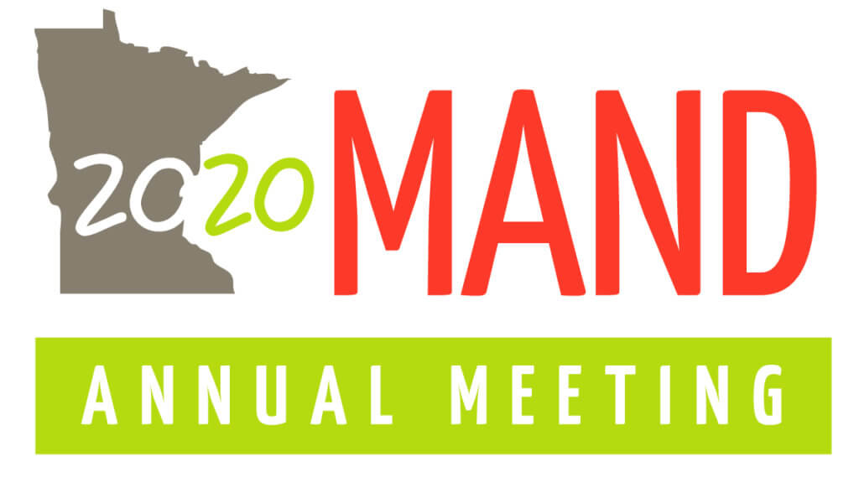

FOOD OF THE FUTURE

LIVE WEBINARS
April 20th-May 1st

RECORDED WEBINARS
May 1st – September 30th

LIVE WEBINARS
Live webinars are offered through Zoom Conferencing and will allow registrants to participate with the speaker. These sessions will also be recorded for registrant access from May 1st – September 30th. Registrants can register for a combination of “live” and recorded webinars.
COST OF SESSIONS
Member: $12/session $184 for all 17 sessions (10% discount)
Non-Member: $17/session $261 for all 17 sessions (10% discount)

THERE IS A REGISTRATION WORKSHEET AT THE END OF THIS DOCUMENT. USE THIS TO DETERMINE THE SESSIONS YOU WANT TO REGISTER FOR AND THE TOTAL NUMBER OF SESSIONS YOU WILL BE PAYING FOR.

MONDAY, April 20th
9:00-10:00am Welcome
MAND Annual Business Meeting/Awards and Scholarships
Updates and Live Q&A
Kristen Williamson, MBA, RDN, LD, President

11:00am-12:30pm FOOD OF THE FUTURE
Eating to Prevent the Apocalypse
Ryan Andrews, MS, MA, RD, RYT, CSCS
SPONSORED BY: Vegetarian Nutrition DPG

“Feeding the world in 2050, in a sustainable manner, will be the biggest collective hurdle humanity has ever faced.” - Joel K. Bourne Jr.

We've hit a dead end. We're not only eating ourselves into illness, but we're eating the Earth's resources into oblivion. Each year we're overcharging our ecological credit card, and our daily food choices play a major role in this accumulating debt. This presentation will cover the various ways in which our food choices influence the planet and you'll come away with practical next actions you can incorporate both personally and professionally.

TUESDAY, April 21st

11:00am-12 Noon FOOD OF THE FUTURE
Meat Me at the Table: Sustainability, Ethics, and Nutrition
Facts About Pork
Riley Larson, MS, RD, FAND
Lori Stevermer, BS
SPONSORED BY: The Minnesota Pork Board

No one protein product can solve the climate crisis, nor is one product inherently superior over another. Nutrition and health are not black and white. An understanding of food sourcing, agricultural practices, nutritional adequacy, and health and disease is necessary to fully assess the uses and limitations of various protein foods. Protein food development is a fast- growing and fascinating area of discussion that perfectly fits into this year's conference theme "Food of the Future."

1:00-2:00pm FOOD OF THE FUTURE
Nutrition for Anxiety and Depression: Microbes, Neurotransmitters and Popular Diets
Kim Rosen-Kulp, RD

40 million adults are affected by anxiety, and over 16 million by depression. As dietitians, how can we help this growing population? This session will explain the emerging research on the gut-brain axis, and how the foods we eat influence communication to the brain. We’ll review stress, inflammation, neurotransmitters, and hormones, and the role they play in one’s mood. Next, we’ll explore today’s popular diets, and evaluate how they can impact depression and anxiety. Finally, Kim will share her real client stories, and how to apply practical diet changes to put what you’ve learned into practice.

WEDNESDAY, April 22nd

9:00-10:00am CLINICAL
Impact of RDN Medication Therapy on Patient Outcomes
Gretchen Benson, RD, CDE, LD
Joy Hayes, MS, RD, CDE, LD

In this session, presenters will share lessons learned from two rural population health initiatives -- a primary prevention program and a type 2 diabetes randomized trial-- where the use of medication therapy protocols were used by registered dietitian nutritionists to improve patient care outcomes.

12 Noon-1:30pm FOOD OF THE FUTURE
Make a Greater Impact Using Non-Diet, Weight Neutral
Approaches to Well-Being Alison St. Germain, MS, RD, LD

Diets are not effective long-term, and weight focused paradigms are not producing desired outcomes. In addition, Health At EverySize® and Intuitive Eating are misunderstood by individuals and healthcare professionals and therefore the framework will be explored with myths debunked. Non-diet weight neutral approaches to well-being will be presented with examples of how to change the language. Specific activities will be provided to attendees to incorporate into assessment and interventions. Attendees will leave the presentation with resources and activities in hand to start using with patients and clients immediately.

THURSDAY, April 23rd

12 Noon-1:00pm FOOD OF THE FUTURE
From RD to IG: Find Your Inner Social Media Maven
Ashley Moyna, MS, RD

Hashtags, filters, and emojis, oh my! Influencers are blowing up social media with non-evidence-based messages about health and nutrition. As nutrition experts, it’s essential we share evidence-based nutrition messages with the public in a fun and engaging way. Learn how to grow a following, create engaging (+ eye-catching) content, develop a personal brand, and
spread research-backed health messages through social media marketing. Whether you’re looking to develop a personal brand or add value to your company’s social channels, this presentation will give you the skills to confidently share your expertise with consumers around the world.

4:00-5:00pm CLINICAL
Neurogastronomy for Preparing Nutrient-Rich Meals People Will Want to Eat
Michele Redmond, MS, RDN, Chef, FAND
SPONSORED BY: Food and Culinary Professional DPG
Taste consistently ranks as the primary reason behind food choices, but consumers often don’t recognize why they like or don’t like certain foods. This session will review how we perceive flavor (taste qualities, aromas and textures) and how social-environment, genetics and eating experiences influence food choices. We’ll explore key attributes of nutrient-rich foods, ingredients and culinary techniques that appeal to consumer palates and strategies to help clients and patients crave and choose more nutrient-rich foods.

FRIDAY, April 24th

9:00-10:00am PROFESSIONAL DEVELOPMENT
Diversifying Nutrition
Jenny Gherau, RD, LD

Learn how to empower students and young professionals from underrepresented minority groups and how to address unconscious and implicit bias to ensure equal access to opportunities. Learn about the impact of unique storytelling and how identity cultivation can be used as an education tool for others and what we all can do to increase inclusivity as nutrition leaders.

12 Noon-1:00pm
UPDATED TIME:
10:30-11:30am CLINICAL
The Role of Exercise and Carbohydrates on Symptoms of IBS in Endurance Athletes
Renee Korczak, PhD, RDN, CSSD, LD

Irritable bowel syndrome (IBS) and associated conditions such as gastrointestinal (GI) distress
exhibit similar symptoms in endurance athletes and may have similar etiologies. Carbohydrates
are a primary fuel for endurance athletes, yet not all carbohydrates are created equal and some
may disturb the gut in athletes who suffer from IBS or GI distress. The purpose of this
presentation is to provide the sports dietitian with an overview of IBS and GI distress etiologies,
review current nutritional strategies to manage these conditions, and provide a summary of
previous clinical trials that used low FODMAP or other carbohydrate-modified approaches to
help treat the endurance athlete. Case study examples will also be incorporated into this
presentation to provide the sports RD with some practical application examples.

MONDAY, April 27th

12 Noon-1:00pm FOOD OF THE FUTURE
The Food Matrix: More Than the Sum of
Nutrients
Katie Brown, EdD, RDN
SPONSORED BY: Midwest Dairy

It is commonly accepted that we eat foods, not nutrients; however, until recently the relationship between diet and health has focused on individual nutrients. Today, the focus is shifting toward the impact of whole foods. The food matrix is an emerging concept that looks at the physical structure of foods and the nutrients and bioactive factors within them may impact digestion,
absorption and health -beyond the impact of individual nutrients. This session will provide a foundation on the food matrix concept and highlight research that suggests further exploration could impact the future of nutrition guidance.
4:00-5:00pm CLINICAL
Updates in Renal Nutrition
Rachael Majorowicz, RDN, CRS, LDN, FNKF

This session will describe the newly updated evidence-based, nutrition practice guidelines for adults with chronic kidney disease. In addition, it will focus on demonstrating how to apply these guidelines in practice to improve patient outcomes while challenging nutrition professionals to discard the restrictive practices of the past and embrace modern, individualized
recommendations to reduce malnutrition and maximize patient quality of life.

TUESDAY, April 28th

12 Noon-1:00pm FOOD OF THE FUTURE
The Savvy Dietitian's Guide to Modern Agriculture
Amy Myrdal Miller, MS, RD, FAND
SPONSORED BY: The National Cattlemen’s Beef Association and the Minnesota Beef Council

Many people love the romanticized “red barn” view of agriculture where a farmer and his wife stand with their beautiful children near their perfect red barn with a few docile cows grazing in a lush, green pasture in the background. But this view of agriculture doesn’t fit with the realities of modern agriculture, much of which relies on technology-driven tools and tough business decisions to successfully compete in a global marketplace.

The talk is designed to help dietitians address complex issues related to sustainable food production with a better understanding of the business of modern agriculture, and a greater appreciation of the pressures farmers and ranchers are facing from consumer demands that may have significant consequences on the availability and affordability of food in this country.

5:30-6:30pm Public Policy “Happy Hour”
Updates and Live Q&A
Tessa Lasswell, MPH, RD, LD, Moderator
Hear the latest from our public policy experts about what is
happening at the local and national levels. FREE!

WEDNESDAY, April 29th

9:00-10:00am CLINICAL
Blenderized Tube Feeding - More than Just a Fad
Kristen Reiman, RD, LMNT

Usage of blended tube feeds continues to increase in popularity, across all patient demographics. This type of feeding entails foods and liquids blended and given via enteral feeding tube. This may be in place of, in addition to, or in combination with commercially available formulas. There are benefits and risks involved with this type of feeding and dietitians are the best resource for guiding patients and caregivers in choosing appropriate foods for a balanced diet and preventing complications. This session will equip participants in identification of appropriate candidates as well as strategies for creation and implementation of blenderized feeds.

12 Noon-1:00pm PROFESSIONAL DEVELOPMENT
Turning Your Contacts Into Contracts – Landing Profitable
Wellness Opportunities
Judith “Judes” Scharman Draughon, MS, RDN, LD

The wellness industry is currently a $4.2 trillion industry! Are you an entrepreneurial-minded RDN who wants to generate revenue from wellness contracts for yourself or your employer? There is ample opportunity for RDNs to approach businesses, organizations, and groups that will benefit from your evidence-based programming, as they seek interventions for their employees or members. RDNs frequently believe that if they aren’t working in a formal wellness setting, they are unable to launch a wellness initiative. You need not have a formal program – opportunities include presentations, culinary demos, one-on-ones, grocery tours, contributing to a newsletter or blog, and more. Take advantage before non-RDNs get there first. Learn how to pitch, close the sale, deliver and evaluate success, gain repeat business, and more. Turn contacts into contracts!

THURSDAY, April 30th

12 Noon-1:00pm PROFESSIONAL DEVELOPMENT
1-2-3 Steps to Storytelling for Nutrition Communications Jean Storlie, RD, MS

Stories awaken the senses, convey emotional insights, and leave listeners pondering new truths. Neuroscience shows that the brain releases a hormone associated with empathy and trust in response to character-driven narratives. But many people think, “I don’t have any stories to tell.” This session can solve that challenge for you. Participants will learn how to tell stories that capture the hearts and minds of their audiences – patients, clients, consumers, or business partners. Both natural or wanna-be storytellers can learn how to create stories of human struggle and triumph that leave the listener pondering new truths. This session will help dietitians find and polish story gems that will enhance their interpersonal counseling relationships and leadership impact. Participants will learn a three-step process for storytelling: 1) find story gems, 2) develop plot and meaning, and 3) polish with salient details.

FRIDAY, May 1st

12 Noon-1:00pm PROFESSIONAL DEVELOPMENT
CPE, CDR + Licensure: Keeping Up
Kori Geinert, MS, RD
Toni Swanson, RDN, LD

Review the recent changes to the Professional Development Portfolio (PDP) and continuing education logging process through CDR and the CPE prior-approval process for your live activities. Geared towards dietitians who have not yet transitioned to the new PDP format, dietetic interns, students and those who have not completed their first PDP cycle.

2:00-3:00pm CLINICAL
Navigating Food Allergies in a Food Service World
Lexi Cournoyer, RDN, LDN

Where will my food be made? What equipment is used? Will it be safe for me to eat? Will I get to eat and dine like every other student? These are all questions students with food allergies face as they head off to college. Food allergies can be a scary and complex issue for both students and their parents to navigate. Registered Dietitians play a huge role in helping to alleviate those fears, instilling best practices, and educating our food service professionals! The purpose of this presentation is to educate RD’s on the basics of food allergies, the laws and legislation in place in the university setting, creating food allergy plans, and how to educate food service professionals to ensure a safe and delicious meal for your food allergy students. A case study will provide an example of how food allergy accommodations look from start to finish.
REGISTRATION WORKSHEET

Check which sessions you want to register for, either LIVE or RECORDED.
Then RECORD the number of sessions you will be paying for here: _______.
Remember that there is a 10% discount if you sign up for all 17 sessions.
USE THIS SHEET WHEN YOU REGISTER & MAKE PAYMENT.
SESSION | CREDIT HOURS | LIVE SESSION | RECORDED  SESSION
MAND Annual Business Meeting 4/20 | FREE
Eating to Prevent the Apocalypse 4/20 | 1.5
Meat Me at the Table: Sustainability, Ethics, and Nutrition 4/21 | 1
Nutrition for Anxiety and Depression: Microbes, Neurotransmitters and Popular Diets 4/21 | 1
Impact of RDN Medication Therapy on Patient Outcomes 4/22 | 1
Make a Greater Impact Using Non-Diet, Weight Neutral Approaches to Well-Being 4/22 | 1.5
From RD to IG: Find Your Inner Social Media Maven 4/23 | 1
Neurogastronomy for Preparing Nutrient Rich Meals People Will Want to Eat 4/23 | 1
Diversifying Nutrition 4/24 | 1
The Role of Exercise and Carbohydrates on Symptoms of IBS in Endurance Athletes 4/24 | 1
The Food Matrix: More Than the Sum of Nutrients 4/27 | 1
Updates in Renal Nutrition 4/27 | 1
The Savvy Dietitian's Guide to Modern Agriculture 4/28 | 1
Public Policy “Happy Hour” | FREE
Blenderized Tube Feeding - More than Just a Fad 4/29 | 1
Turning Your Contacts Into Contracts – Landing Profitable Wellness Opportunities 4/29 | 1
1-2-3 Steps to Storytelling for Nutrition Communications 4/30 | 1
CPE, CDR + Licensure: Keeping Up 5/1 | 1
Navigating Food Allergies in a Food Service World 5/1 | 1

