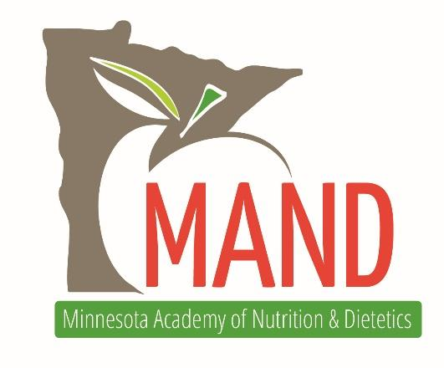
MAND 2021 ANNUAL MEETING – CALL FOR SPEAKERS

The Minnesota Academy of Nutrition and Dietetics will hold its 2021 Annual Meeting on Monday, May 3rd (full day) and Tuesday, May 4th (half-day) at the Marriott Southwest in Minneapolis. The theme of the annual meeting is Progressing Through the Pandemics, focusing on what we have learned during the pandemics of coronavirus and racism and how we can move forward as a country.

There will be three tracks for our annual meeting:
Track 1 - Progressing Through the Pandemics
Track 2 – Leadership
Track 3 – Clinical

Keynote Speakers will be limited to Track 1 and we anticipate 4-5 Keynote Speakers. Break-out Sessions will be offered for all three tracks, with 10-12 Break-out Sessions expected. Sessions must be Level II or Level III.

Category II: Assumes that the participant has general knowledge of the literature and professional practice within the area(s) covered. The focus of the activity is to enhance knowledge and application by the participant.
Category III: Assumes that the participant has thorough knowledge of the literature and professional practice within the area(s) covered. The focus of the activity is synthesis of recent advances and future directions.
We will host a pre-Annual Meeting virtual preview session in March 2021 with one of our Keynote Speakers. If this is of interest to you, please include that in your application.

DESIRED SUBJECT MATTER FOR TRACK 1 – Progressing Through the Pandemics
- How the COVID Pandemic has impacted dietitians and/or clinical care; exposed inequities in access to healthcare and/or healthy foods; impacted vulnerable populations; exposed weaknesses in our supply chains, etc.
- Future opportunities for telemedicine and remote clinical care
- Diversity in nutrition including the status of diversity in the field; successful initiatives to address the lack of diversity through recruitment or within educational institutions; cultural competency; understanding the changing demographics of patients/clients
- Are we training future dietitians on implicit bias, inequity, cultural competency?; successful models/initiatives for changes in dietary education
- Historical perspective on healthcare, its roots in European ideals and its Western medicine focus; how that has impacted treatments, access and inequity
- Bias in healthcare for black, indigenous, people of color and the LGBTQ community
- Individuals or organizations who have success stories in addressing bias/systemic racism and insights to share
- Strategies for addressing weight bias in healthcare including weight neutral approaches to health promotion
- Clinicians interested in submitting should consider the opportunity to co-present with individuals outside of the healthcare field

DESIRED SUBJECT MATTER FOR TRACK 2 - CLINICAL
- Updated nutritional/dietary guidance or upcoming guidance as it relates to dietetic practice
- Emerging trends in nutrition and diet advice from a consumer perspective – what are consumers learning via social media? Encouraging evidence and combatting unproven claims
- Sessions for specific practice areas: parenteral nutrition, diabetes, elder care, heart disease, prenatal, etc.
- Emerging evidence on subject matter related to dietetic practice
- Reimbursement trends

DESIRED SUBJECT MATTER FOR TRACK 3 - LEADERSHIP
- Public policy and advocacy
- How to be an ally in addressing racism, inequity and social justice
- Understanding your implicit bias
- White privilege in the nutrition field
- Knowing and promoting your value as a dietitian
- Asking for a raise and other challenging work-related issues
- Exploring non-traditional career tracks in dietetic practice
- Communication skills with patients/clients and colleagues
- Self-care
- Strengthening your personal/professional brand

PROCESS
- Complete this form and submit your proposals. You may submit up to 3 ideas for sessions within each track [link here]
- You will also be asked to upload your CV/Resume and a brief bio
- You will be required to disclose all conflicts of interest
- MAND is actively seeking speakers who identify as black, indigenous, people of color and/or LGBTQ.
- The deadline for submissions is September 30, 2020
- Speakers will be notified of their status no later than November 15, 2020

POSSIBILITY OF A VIRTUAL MEETING
MAND will be monitoring the Coronavirus Pandemic and will notify speakers of the decision to switch to a virtual meeting by March 1, 2021. If there is a virtual meeting, the dates will be the weeks of May 3rd and May 10th, with time slots at 9a, 12 noon or 4p (CST).

QUESTIONS? Please contact us at mand@eatrightmn.org.

